Extended Day

Before and After School Care

Parent and School Partnership

Handbook September 2020

Welcome
A warm welcome to our before and after school care. We hope this handbook will provide you with all the information you need. Our before and after school care is available for children attending St. Swithun’s Catholic Primary School & Sunbeams Pre-School. It runs from 7.30 am to 5.45 pm during term time only. We are Ofsted registered as part of the main school. Our before and after care service has to be entirely self-funded; it is not permitted for money from the school budget to be used to finance services provided through the Extended Day service.

Fees
If you pay by childcare vouchers, tax-free childcare or childcare grant from Student Finance England, you will be able to book your sessions without having a credit on your Extended Day account; however, you MUST make the school office aware of this and advise your childcare voucher provider name or your tax-free childcare unique reference number; we will also require screenshots of tax-free childcare payments to be emailed through. If you do not pay by these methods, your extended day account will have to be in credit before any bookings can be made online.

Before School Care Fees
Morning session (E) from 7.30 am to 8.00 am (Breakfast included) | £2.00
Morning session (M) from 8.00 am to 8.45 am (No food provided) | £3.00
After School Care Fees
Afternoon session (A) from 3.30 pm to 4.30 pm (Small snack included) | £4.50
Afternoon session (L) from 4.30 pm to 5.45pm (Light meal, served 5 pm) | £4.00

Cancellations
Bookings can be cancelled online up to Midnight 48 hours prior to the session date. Failure to do so will incur full fee payment.

Routines
- When a child is dropped off at Before School Care, the adult must sign their child in and record their child’s arrival time.
- At 3.30pm Early Years and Key Stage 1 children are collected from class by a staff member and escorted to the meeting place.
- Key Stage 2 children will congregate at the meeting place where a member of staff will greet them.
- A register will be taken before proceeding to the Hut.
- On arrival to the Hut, the children will have a snack, before choosing from a range of outdoor and indoor activities.
- Children, who are joining us from an after-school club at 4.30 pm, will be collected by a member of the Extended Day Team and walked across to the Hut.
- Light meal is served at approximately 5 pm.
Collection
- A member of staff will greet the child’s responsible adult and call the child to collect their belongings. The child MUST be signed out by their responsible adult with a record of the time they are leaving.
- Staff cannot allow children to be collected by someone unknown to them unless that person is able to give the designated password stated on the registration form.
- If there were any doubts about the collection arrangements, the child’s parents would be contacted.
- If the parent/carer is running late, they must call the Extended Day Team mobile on 07419.829478 stating the child/ren’s name(s) and the new arrangements for collection. Please note extended day closes at 5.45 pm.
- If a child is not collected, staff will make several attempts to contact the parent, carer or designated adult; failure to make contact will result in the After School Care leader calling Mr Olive, Headteacher or Mrs Verhiest, Deputy Headteacher, social services may also be called.
Content of the Care
There are a variety of activities each morning including painting, construction, craft, games and a reading area. At 8.35 am, children help to clear away the activities. At 8.45 am, the children collect their belongings and leave to go to their appropriate playgrounds. A staff member escorts Pre-School, Early Years and Key Stage 1 children.

At after school care the children will receive a snack and drink before choosing between outdoor activities (weather permitting) in the Key Stage 1 playground or inside activities. Inside, children can be involved in any free play activity: a selection of art and craft projects, construction apparatus, jigsaws or table games. We focus two nights on play and two on creation. We also have a weekly rotational film night.

There is a creative activity every week linked to the term’s theme, allowing the children to explore their artistic side and learn new skills. This can include cooking, sewing, modelling or painting. As part of the calendar, we also observe and plan special handmade gifts for family members, giving the children an opportunity to make something for a loved one on a celebratory occasion. We are continually reviewing our activities, and where appropriate differentiate according to age and ability, whilst ensuring we cater for a range of different interests.

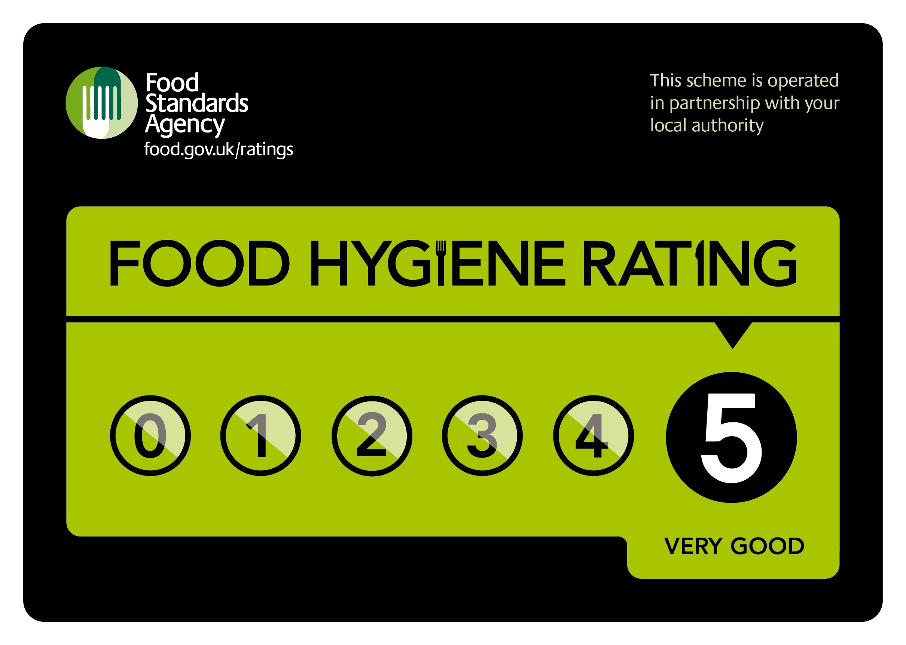
Snacks and Food
We have retained our Food Hygiene Rating of 5 Stars and all food is prepared in accordance with food standards. Children have access to water at all times.
- An example breakfast will comprise: cereal, toast and yoghurt with milk or water to drink
- A light snack will be served at approximately 3.45 pm
- 5 pm approximately a light tea will comprise, for example: bagel with a side salad, with milk or water to drink
- Where possible children will help to prepare food and clear away afterwards
- Children are taught about hygiene, are asked to wash their hands before sitting down at the table, expected to respect others, share food, pass items to one another, eat politely and encouraged to have a small taste of the foods they may not have eaten before
Food Allergies
If a child has a diagnosed food allergy, it is the responsibility of the parent/carer to provide the Extended Day Team with a comprehensive list of food items that can and cannot be eaten by their child. Any information about food allergies or special dietary requirements must be stated via email when booking. Staff will cater for allergies or special dietary requirements where possible. Children are not permitted to eat their own snacks.

First Aid
Several members of the team are fully trained in paediatric first aid. The procedure for dealing with an accident, illness or injury is the same as in the school and the children are familiar with the system. There is a first aid box in the hut. The accident will be recorded for the parent(s) to see in accordance with the school procedures. If it is a more severe accident, emergency contacts will be called.

Medicines
If a child has a diagnosed specific medical need, e.g. EpiPen, inhaler and/or other prescribed medicines, it is the responsibility of the parent/carer to provide Extended Day Team with a complete set of medicines, in addition to those held in the School Office. If the medicine is for short-term use only, the parent must fill in a medicines form available from the Extended Day Team.

Special Needs
We believe all children have the right to share in the Extended Day Care environment and activities. We will do our best to accommodate all children within our group. However, we cannot guarantee to be able to offer a place to all our pupils.

Behaviour
Before and After School Care operate in conjunction with the relevant policies from St. Swithun’s Primary School. In order to enable the children to become responsible and caring members of the community, we:
- Act as positive role models
- Promote good manners
- Encourage respect for self, others, and property
- Instil self-discipline
- Develop opportunities for children to have a voice
Penalty Charges
The fine for late collection after 5.45 pm is £15 per child; this is in addition to the standard session charge. If you frequently collect your child late, we will issue a warning and should this occur more than three times, a fine of £20 per child will be applied, and you risk losing your place on Extended Day Care.

Communication
Parents must make sure staff have information about variations in collection routines whenever possible:
Calling between 8 am - 3.30 pm | Call School Office on 023.9282.9339
Calling between 3.30 pm - 8 am | Call After School Care on 07419.829478 stating full names of all children
Email | extendedday@st-swithuns.portsmouth.sch.uk  This is monitored during school hours, term time only
In the event of a child not arriving when they are due to attend an After School Care session, a member of staff would be informed and school procedures will be followed.

Complaints
Our aim is to provide an outstanding service for your child. However, should there be any problems that arise, please speak in the first instance to a member of the Extended Day Care staff. If you wish to take it further, we can then advise you on how to follow the school’s complaints procedure.

Our Team

Sarah Hankin-Gould, Supervisor

I joined the Extended Day team in September 2019. I have lots of experience working in schools, primarily as a TA within the early years, and I can be found in the Bumblebee class during the day. I have also run successful 'out of hours' and holiday clubs for children aged 2-11. I enjoy helping children to learn and grow, and knowing that no two days are ever the same! When I'm not at work I enjoy spending time with friends and family, reading and running.

Marlene Carter

I started assisting with the Early Years Team and working as a Midday Assistant in 2016. I have an NVQ in Childcare, Food Hygiene, and Paediatric First Aid. I love working with the children and being part of the team. Outside of school, I like spending time with my family.

Tanya Hearne

I joined the Extended Day Team in November 2017. I am currently studying a level 2 Business Administration course at Highbury College. I enjoy working with children and have worked with children between the ages of 2- 11 years in various pre-schools and schools in Portsmouth. I have qualifications in Early Years, Teaching Assistant, First Aid and IT. My hobbies range from reading historical novels, baking, cooking and creating my own greeting cards. I also love spending time with my family going on long country and seaside walks.

Lisa Kirk

I have been a teaching assistant for seven years and worked at St Swithun’s for three years, currently in Kangaroos class. The opportunity to work in Before School Care and I grabbed the chance, working Tuesdays, Wednesdays and Thursdays and really enjoy starting the morning with our super Key Stage 1 children. It’s great to get to know the children from the lower year groups, through playing games and exploring arts and crafts.

Lubova Sabir

I am originally from Latvia and have been in Portsmouth since 2007 and have two children who attend St Swithun’s. I have a degree in Business Management and speak Russian, Latvian and English. My interests are gardening, cookery, reading and sport and love working in Extended Day Care with the Key Stage 2 children. I also work as a lunchtime assistant, which is always a busy time helping to organise games and activities with Key Stage 1 children. So I get to meet lots of children throughout the day.

Veronika Sibanda

I joined the Extended Day Care team in September 2018. I am also a teaching assistant at St Swithun’s. I have an NVQ level 3 SEN, a level 3 TA qualifications as well as paediatric First Aid. I enjoy working with children of different age groups and I have 6 years experience of working with SEN children whose English is an additional language. My hobby is swimming and I love any kind of art and craft activities. My first language is Czech, but I understand Slovakian and Polish too.

Thank you for choosing Before and After School Care. We look forward to welcoming your child.

